Jam On It 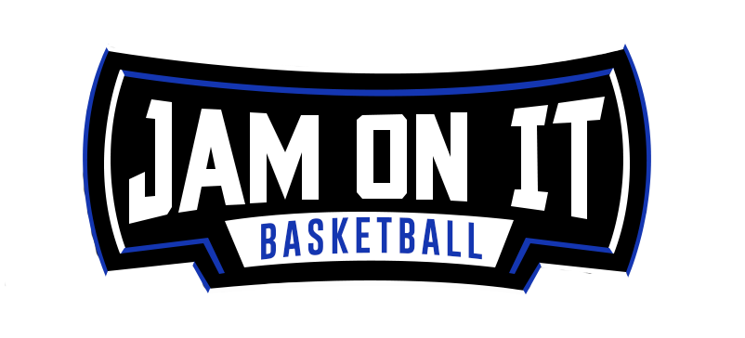
Equipment Rental Pricing
Updated June 1, 2020

Jam On It is an industry leader in providing sports equipment for tournaments, special events and projects. We are here to assist you in creating an awesome event experience.

Things you should have done prior to requesting a quote.
Overall event budget
Dates and location of the event
Cad Drawing of potential space
Is the space for the equipment require union Staff? Will they let outside groups set up equipment?
Is this an AAU licensed event?
Do you have additional insurance coverage?

Items to Consider for All Rentals
These are suggested items that you need to factor into the total cost. Jam On It can provide these services at an additional rate.

Forklift
Suggested 5000lb capacity forklift with 6ft forks and certified operator
Labor
You can recruit volunteers or hire staff to set up equipment
Shipping
We will help figure out the number of trucks /trailers needed
Carrier must be approved by Jam On It
Estimated Shipping Costs per Trailer
One-way approx. $2-$4per mile
Example
1 wood floor and 2 baskets can fit on (1) 53’ flatbed trailer
6 snap courts basketball courts can fit on (1) 53’ box truck or flatbed
6 snap courts volleyball courts and 12 standards can fit on (1) 53’ box truck

These are quick estimated cost of some of the equipment for sporting events. These are just estimating for you budgeting purposes. Cost will vary depending on the time of year, location of event, and duration of the event.

Wood Courts
Time Price
1-7 days $10,000/ct
8-30 days $20,000/ct

Basketball Snap Courts (Standard 90'x52')
$600/ per court
$200 to $1000 per basket

Volleyball Snap Courts (Standard 80'x42')
$400 per court
$200 per set of standards

Other Items

Snap Court by Sq. Ft. $.20/ Sq. Ft
Table Top Score clock $50/clock
Rolling Score clock $100/clock
Shot Clocks $100/set

Load per Trailer
Wood Courts | 1 Wood court w/ 2 baskets
Basketball Snap Court | 6 floors
Volleyball Snap Court | 9 floors
Snap Court Crates (1440 SF) | 22 Crates
Volleyball Standards | 36 Standards (18 sets)
Full Volleyball Courts | 6 Full courts (tile plus 12 Standards)
Spalding Hoops | 24 Hoops
Hoop-It-Up Hoops | 50 Hoops
Big Baskets (BPI3000) | 8 Hoops
Big Baskets (BPI8000) | 6 Hoops

